Breanna D. Bryant
Southern New Hampshire

CS 340
19 April 2026

This submission presents a Jupyter-based Dash application that enables the Grazioso Salvare team to explore animal shelter data and identify dogs suitable for water rescue, mountain or wilderness rescue, and disaster or tracking missions. The dashboard runs inside Jupyter using JupyterDash and connects to a MongoDB database through a small CRUD module. Users interact with a set of radio buttons to choose a mission profile, an interactive table that supports sorting and filtering, a live record counter, a breed distribution visualization, and a map that centers on the record selected in the table.
The application opens with the organization’s logo, the author and date stamp, and a default view showing all dogs. Selecting a mission profile immediately refreshes the table with the corresponding records from MongoDB and updates the record counter to reflect the size of the filtered result set. The breed distribution chart recalculates from the rows currently present in the table so that it always matches the user’s view. Clicking a single row selects that record and updates the map to the latitude and longitude stored for that animal; the marker tooltip shows the breed and the popup displays the animal’s name. The screenshot included with this README shows the application running in JupyterLab with the header, the radio button filter, the record counter, and the populated data table visible.
The code base is implemented in Python 3.11 to leverage its mature data ecosystem and to remain consistent with course requirements. MongoDB is used as the data store because its document model aligns naturally with JSON-like shelter records and supports flexible filtering without rigid schemas. A custom CRUD_Python_Module exposes an AnimalShelter class so that database access remains isolated from the user interface and can be modified without changing the app. Pandas converts MongoDB query results into DataFrames, which simplifies aggregation for the breed chart and prepares rows for the Dash DataTable. The view and controller logic is built with Dash and Plotly Express so that interactivity can be written entirely in Python. Mapping is handled by dash_leaflet, which integrates the OpenStreetMap tile layer and provides markers, tooltips, and popups with minimal configuration. JupyterDash allows the entire application to run inline in JupyterLab or Jupyter Notebook, which matches the expected workflow for the course.
To reproduce the project, install Python 3.10 or 3.11 and ensure that JupyterLab or Jupyter Notebook is available. Install the required libraries using pip for jupyter-dash, dash, dash-leaflet, pandas, pymongo, numpy, and matplotlib. Place the notebook titled ProjectTwoDashboard.ipynb, the CRUD_Python_Module.py file, and the logo image named Grazioso Salvare Logo.png in the same working directory. Confirm that a MongoDB instance is accessible, either through a local server or MongoDB Atlas, and that it contains the AAC animal shelter dataset. Open the notebook, verify the credentials in the username and password variables, and run all cells from top to bottom. The app will render inline and present the interface shown in the screenshot.
The application begins by connecting to MongoDB through the AnimalShelter class and loading records into a DataFrame, removing the MongoDB _id field to avoid serialization issues in the table. The radio button control triggers a callback that executes a mission-specific query. For water rescue, the query returns intact females within a target age window and a small set of water-capable breeds. For mountain or wilderness rescue, the query returns intact males within a similar age window and a list of breeds associated with rugged conditions. For disaster or individual tracking, the query returns intact males with a slightly wider age window and breeds commonly used for tracking. The callback returns the filtered records as dictionaries suitable for the DataTable. A second callback counts the rows to produce the “record(s) showing” label. A third callback builds a breed distribution pie chart using Plotly Express based on the derived data from the table so that the chart always reflects any filtering or sorting performed by the user. A fourth callback applies a subtle highlight to any columns selected by the user to improve readability. The final callback updates the map by reading rubric-specified columns for latitude and longitude, with guard clauses that display a friendly message if a record lacks coordinate data.
I implemented the CRUD module, validated the database connection, and loaded the dataset into Pandas. I then created the Dash layout with the logo, identification header, filter controls, table, record counter, chart area, and map container. After that, I developed the callbacks in sequence: first the data filtering tied to the radio buttons, then the record counter, then the chart recalculation based on the table’s derived data, and finally the map update tied to the selected row.
During development I encountered indentation errors in the callback decorators that were caused by a mix of tabs and spaces combined with wrapped argument lines. I resolved these issues by converting all indentation to four spaces and placing each @app.callback decorator on a single line so that no wrapped indentation was required. I also removed a duplicate id declaration on the DataTable and corrected mismatched parentheses in the layout. Another issue involved the MongoDB ObjectId field causing serialization problems; dropping the _id column in Pandas eliminated the error. A final challenge was handling records that lacked geographic coordinates; adding try and except logic and returning a clear message prevented the map from failing.
I verified that each filter produced the expected subset of records by manually inspecting several returned rows against the criteria for age, sex upon outcome, and breed. I confirmed that the record counter changed as filters were applied and that the pie chart updated to reflect only the visible rows in the table. I selected multiple rows to ensure that the map centered correctly and that the marker tooltip and popup displayed the appropriate fields. I also tested negative conditions such as an empty dataset and records without coordinates to ensure that the interface displayed an informative message rather than an error.
The notebook is designed to run in Jupyter with JupyterDash using the inline mode. If a standalone deployment is desired outside Jupyter, the final line can be adjusted to run a normal Dash server, but that is beyond the scope of the current submission. Credentials should be stored securely if the application is ever moved outside of the classroom environment, and the CRUD module can be adapted to read from environment variables.
The data is used to support rescue outcomes and should not contain or reveal personally identifiable information. Data quality must be reviewed periodically because errors such as incorrect coordinates can mislead operations. Access to the database should be limited to authorized users, and passwords should be rotated regularly.
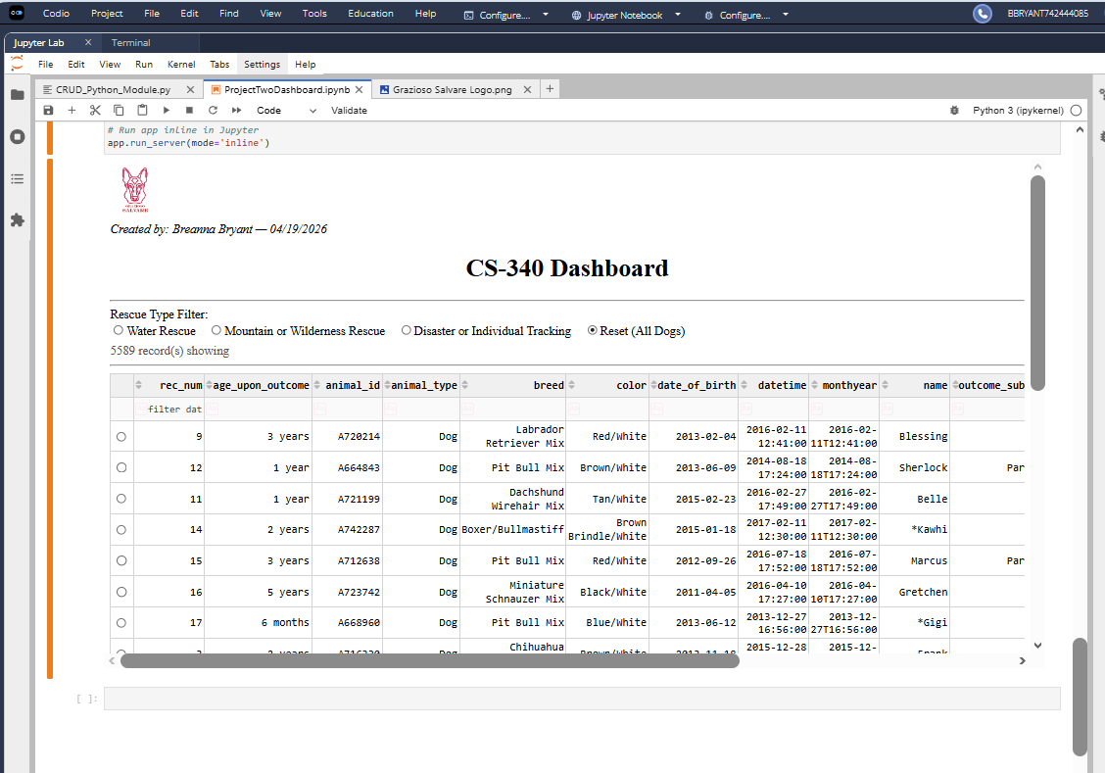
The completed dashboard provides a concise, interactive interface for filtering shelter records, visualizing breed distributions, and locating individual animals on a map. The design keeps the data pipeline simple, relies on well-supported Python libraries, and can be reproduced by following the installation and execution steps described above.

